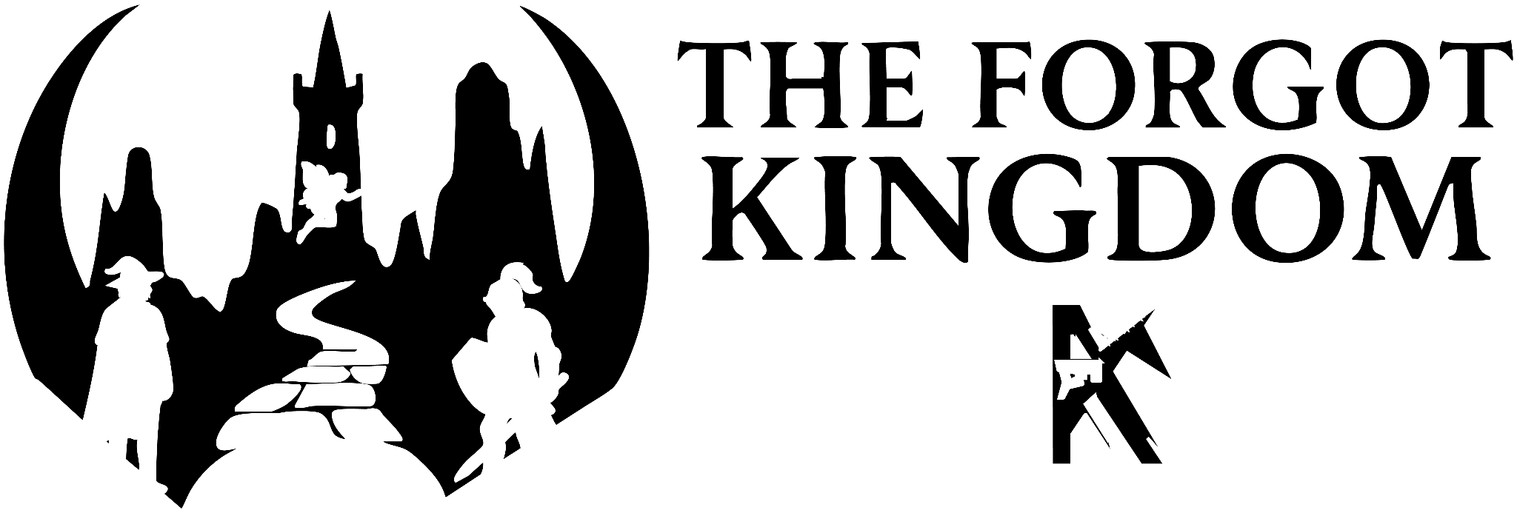

By Kyle Young

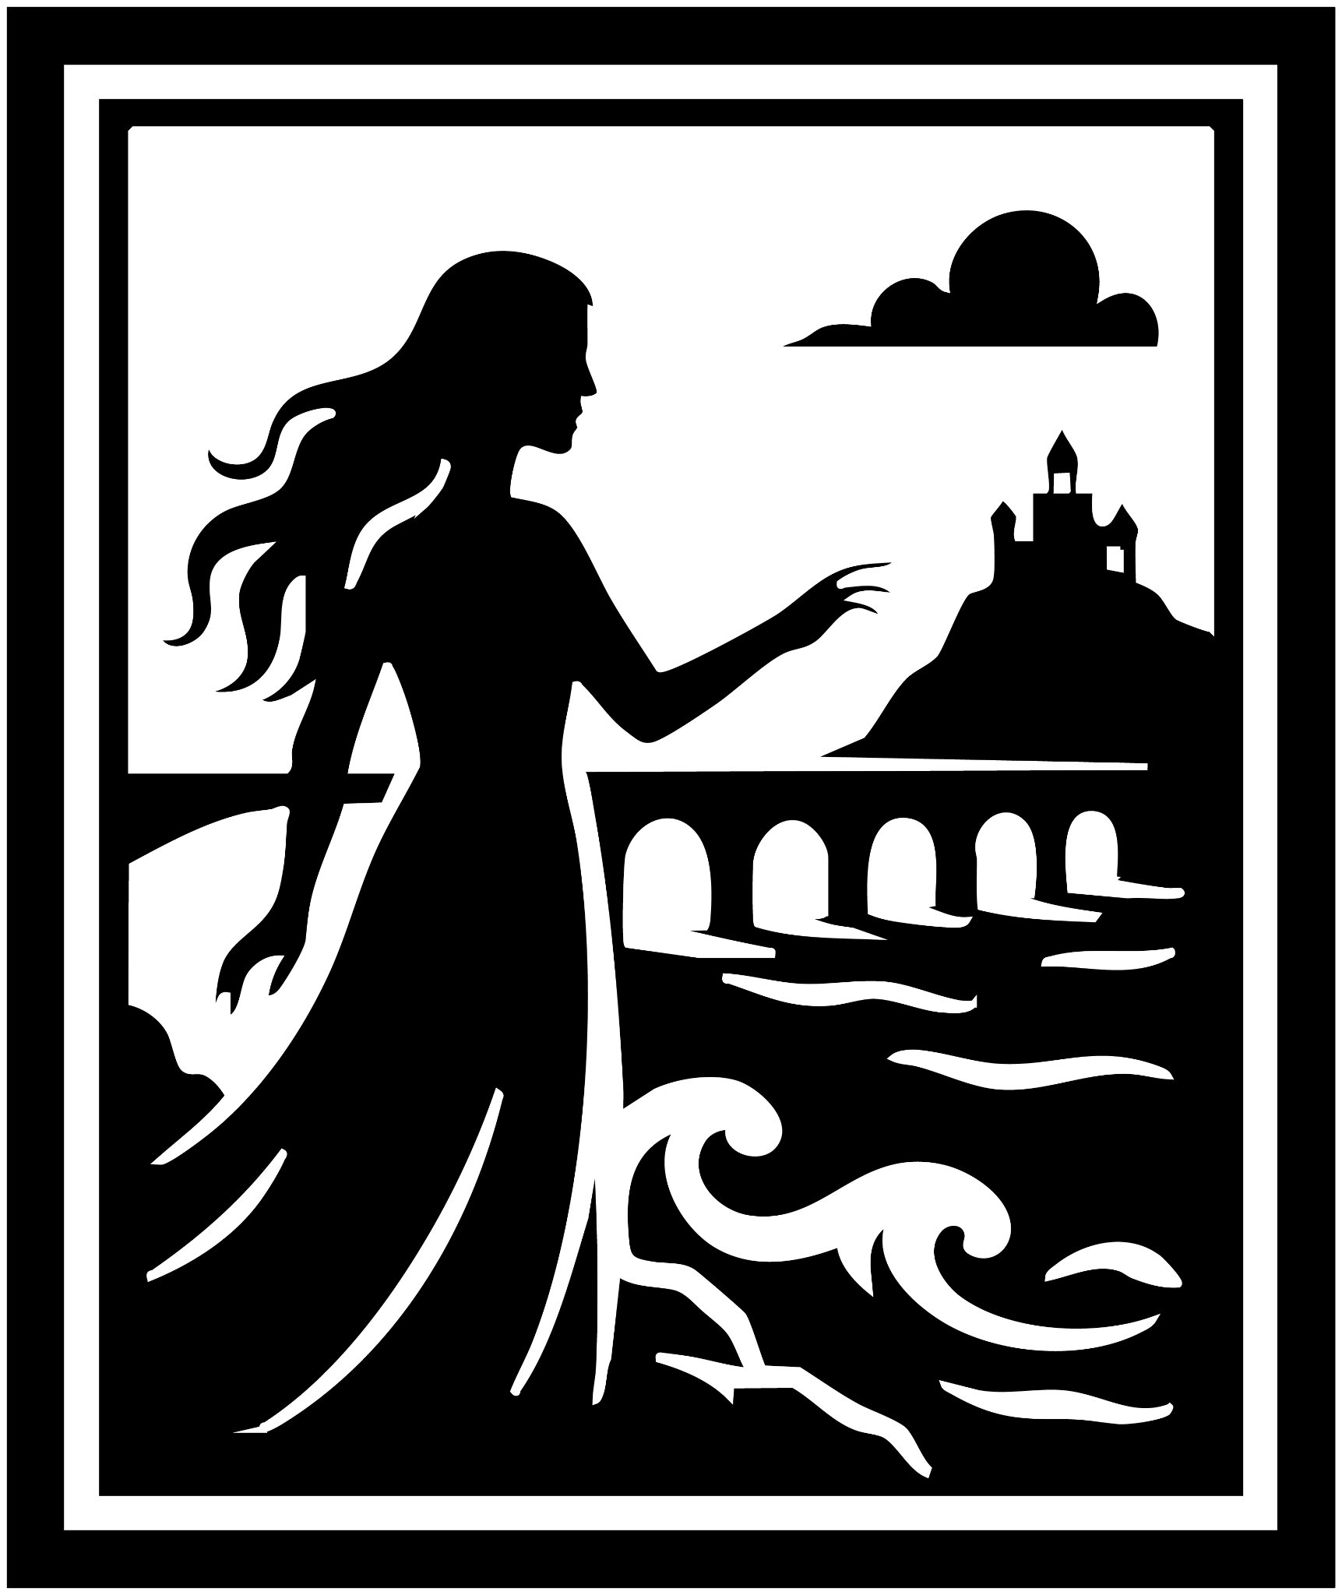

The Legend
Long time ago, before the Cataclysm of Magic laid waste to empires, there stood upon the sea a kingdom bright with riches. Its halls gleamed with gold, and its fields sparkled with diamonds beneath the sun. Yet no treasure within its vaults matched the treasure hidden in the heart of one of its daughters
She was born with the cursed gift of the Mindseer. With a single glance, she could pry open the thoughts of men as though they were coffers with broken locks. And with the crook of her finger, she could pull their will as a puppeteer pulls a string.
The girl learned swiftly that such a gift brought no love. If revealed, her king would bind her to the throne as his weapon, her people would kneel before her in fear, and never again would she know truth upon a tongue. So she hid herself, veiling her eyes, laughing hollow laughter among her friends, and carrying her secret like a blade concealed in velvet.
But no secret lies buried forever.
Years passed, and a foreign king crossed the waves. He spoke of friendship, of trade, of a bridge to bind island and mainland. The island king, blinded by gold’s glitter, agreed. Stone by stone, the bridge grew, stretching like a serpent’s back across the sea.
Yet when the final stone was laid, the stranger came not with gifts but with armies. Witches cloaked in stormlight, wizards dripping with fire, and soldiers thirsting for plunder spilled across the bridge. The islanders gathered with torches to greet their guests, only to find their feast had become their funeral.
Steel clashed, fire shrieked, and the throne room filled with death. The island king struck bravely but was as a candle before the storm. Then the woman rose. The hidden Mindseer tore open her gift, and in an instant, men dropped their blades, their eyes rolling with terror as she bent their thoughts into knots.
Her people cried out in awe and dread, for she was no longer their friend, but something greater and more terrible.
The witches and wizards, unbent, hurled spells against her. Light clashed with shadow; curses and blessings tangled. Soldiers forgot their names, wandering like newborn babes. Old wounds knit together, limbs grew where none had been, and wicked charms cast by the invading king shattered.
But mingled power is a thing untamed. The very stones groaned. The sea clawed higher. Towers fell into the waves. With a roar, the island kingdom broke apart, dragged screaming into the deep. The bridge cracked and crumbled, swallowing both foe and friend.
The foreign king fled, his army broken, but the island was gone.
Upon the shattered gate, half-sunk in foam, words were carved:
“Free the witches,
And you shall gain the gift of forgetting,
The gift to break any curses,
And the gift to reclaim what was once lost.”

Many knights set forth to follow the riddle, but none found the path. Their bones litter the shores of forgotten coasts.
And it is told that the woman—neither dead nor living—still lingers beneath the waves. She waits in darkness, yearning for the kiss of the sun upon her face. But woe to the one who frees her, for gifts such as hers demand a price, and the sea never yields what it has claimed.

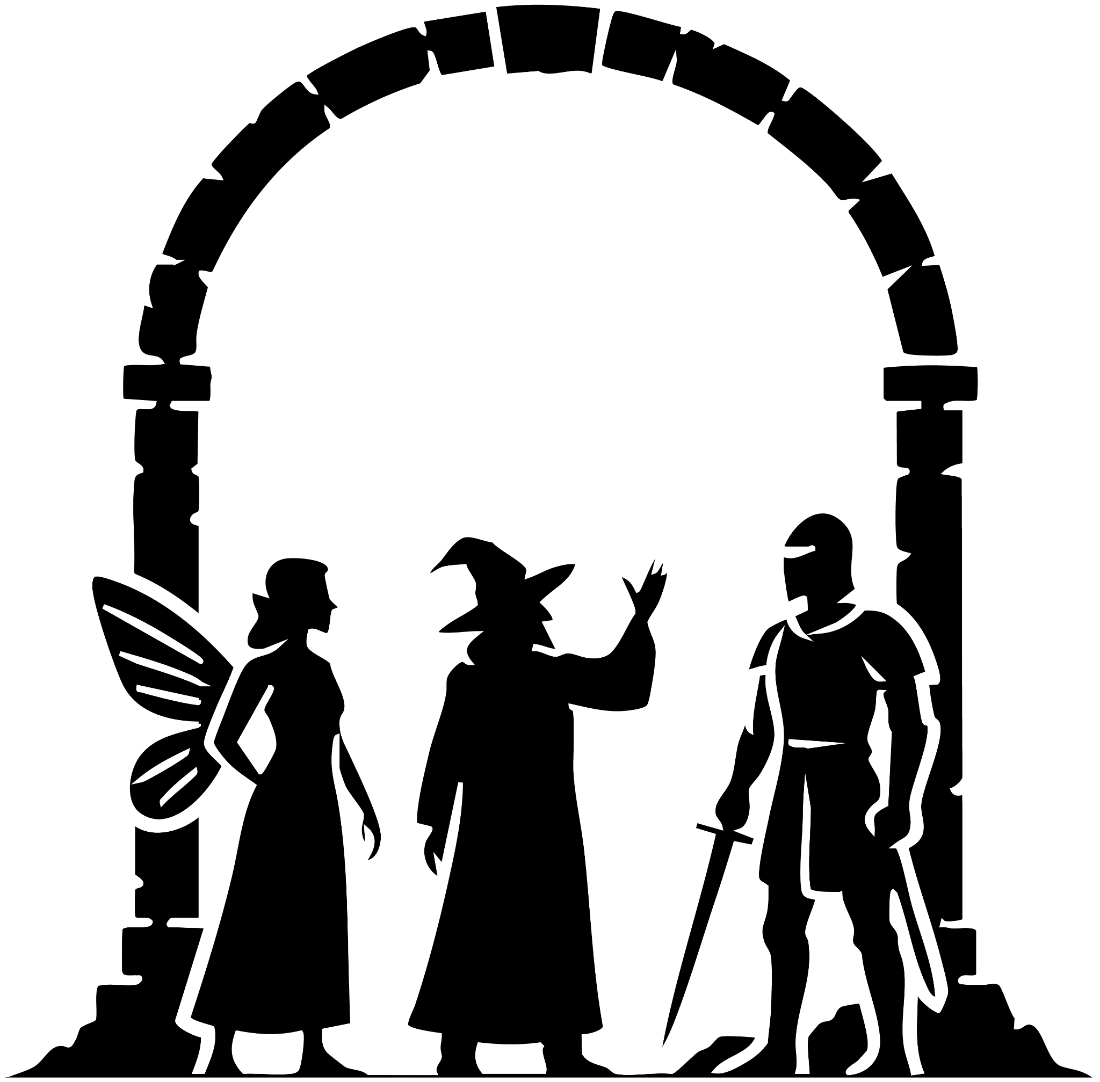

The Three
Alatar, a young wizard in a weathered blue cloak and pointed hat, sat upon the cold stones of the broken bridge entrance, gazing up at the words carved above the gateway:
“Free the witches, and you shall gain the gift of forgetting,
The gift to break any curses,
And the gift to reclaim what was once lost.”
As Alatar closed his eyes and lifted his hand toward the inscription, he felt the stir of magic. It rushed through him like a storm—like a power he had once known. When he opened his eyes, they glowed with blue light. He looked down at his hands and saw bone shining through skin, his flesh as thin and fragile as paper over glass. Screams echoed in his mind, and a tear slipped down his cheek as the magic dragged him into memory. His hands began to dissolve, pain searing through him—until a hand touched his shoulder.
Alatar’s eyes flickered back to their natural green, and his hands returned to their usual bony white. He turned sharply to see who had touched him, only to find a human-sized fairy. Startled, he leapt up from the cold stone floor.
“What do you want?” he demanded.
The fairy only smiled. “I want the path to reveal itself.”
Alatar took a step back. “Is that all you want?”
She stepped closer, opening her hand as she spoke. “I see you don’t trust my kind. So let us begin properly—my name is Hermione.”
Alatar looked from her hand to her eyes. “It is hard to trust someone whose touch opens the mind. And after the part your race played in the Cataclysm that destroyed most of magic? No, I do not think I will.”
Turning away, he placed his palm against the stone gate, feeling the hum of ancient power. Behind him, Hermione asked, “Then what is it you seek?”
Alatar turned back. “The gift to reclaim what was once lost. And you?”
Hermione turned, showing her back. Black metal chains bound her wings tight against her shoulders. “I seek to break any curse.”
Alatar stepped toward her. “What happened?”
Hermione’s smile trembled, masking pain. “I tried to stop a war—or, as some would say, the Cataclysm.”
Alatar froze. “If you were there at the Cataclysm, you would be over a hundred years old.”
Her smile deepened with sorrow. “Yes. A hundred years of not being able to fly.”
He raised his hand toward her bound wings. “May I?”
“Go ahead,” she whispered.
Alatar hovered his hand over the chains, feeling the ancient power that sealed them. His eyes turned black, his breath caught—and suddenly he collapsed. Hermione caught him before he struck the floor. As his eyes shifted back to green, she found herself pulled into his mind.
There she saw Alatar arguing with a man.
“We could save her,” Alatar cried, “if shamanism still existed. But it died with the Cataclysm!”
The man gripped his shoulder. “We will find a way. I don’t even understand how this happened.”
Alatar rifled through a book, muttering, “I thought I found a way to bring magic back.”
The man shook his head. “Those books only show what was lost. We can never have it again.”
Alatar looked up fiercely. “We cannot give up. We must push, and one day we will reclaim it. We have to.”
Flipping pages, he found a spell and whispered, “This will work.” He strode off, the man following. Hermione stepped closer to the book and saw its title: Blood Magic. But before she could read further, she was torn out of Alatar’s mind.
She blinked awake to find him before her on the floor. Rising, he glared at her. “You had no right.”
“I didn’t mean to,” Hermione pleaded.
Her sorrowful gaze softened him. He sighed. “The magic binding your wings—it is ancient. Very old.”
Hermione rose just as a knight entered, sword in hand.
“Who are you?” the knight demanded.
Alatar stepped forward. “My name is Alatar, and this is Hermione.”
The knight lowered his blade with a sneer. “Perfect. A wizard and a fairy—just what I needed.”
Before Alatar could answer, the text above the gate blazed with blue light. The stone doors shuddered and opened, revealing a crumbling path as the seas parted, laying bare a road to the sunken kingdom.

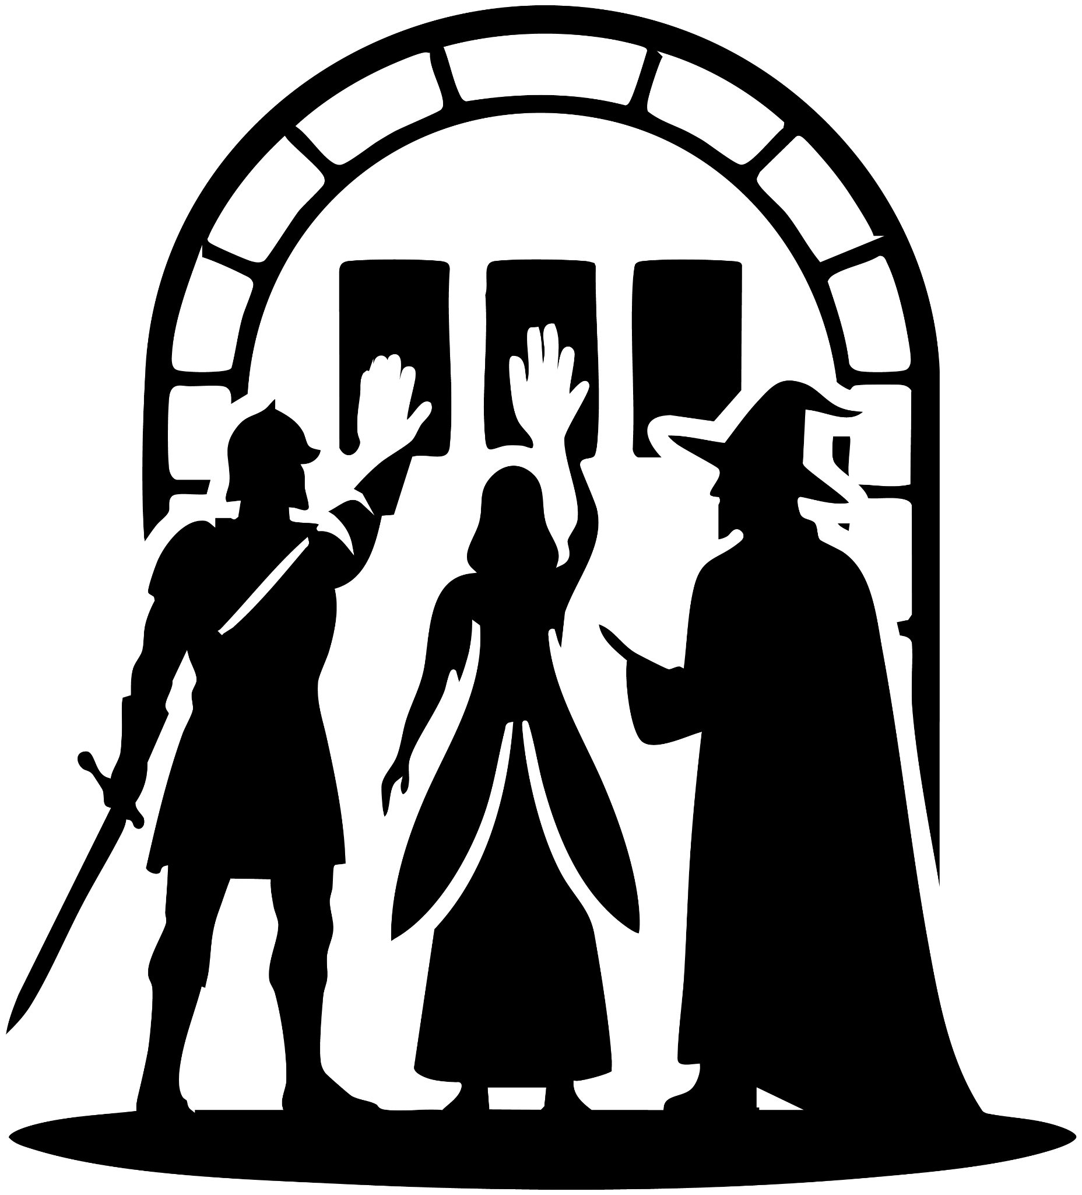

The Path
As the knight stepped through the gate, he said, “My name is Nycolas.”
Alatar and Hermione followed him, the sound of crashing waves all around them. The sea struck against a shimmering barrier of magic, holding the waters at bay.
“Nycolas,” Alatar asked, “are you here to forget something?”
Nycolas stopped and turned to look at them. “No. Why do you ask?”
Hermione and Alatar exchanged a confused glance. Hermione stepped closer, touching his shoulder. “Then why are you here?”
Nycolas’s jaw tightened. “I’m here to kill the Mindseer.”
In that moment, Hermione’s power slipped into his mind. She saw him surrounded by blood, his hands soaked in it, his voice screaming into the void. Nycolas wrenched away from her and drew his sword, pressing it against her throat.
“Give me one reason not to kill you right now!” he snarled.
Alatar raised his hands. “Wait! Everyone—just wait.”
Hermione met Nycolas’s eyes and whispered, “What are you running from?”
His blade pressed closer, cutting her skin. A single drop of blue blood trickled down.
“Everyone calm down,” Alatar said firmly.
Nycolas shot him a glare. “You’re no more trustworthy than she is, wizard. I should have killed you both already.”
Alatar held his ground. “Think about it. The gate only opened when all of us were inside. For whatever reason, it allowed us in together.”
Nycolas sneered. “No. The gate opened because I arrived. This is my quest.”
Hermione’s voice rose sharply. “This is our quest. Didn’t you see the three icons outside? One for each of the gifts. We must work together. I’m not asking for your trust—but I am asking you not to kill me the moment I turn my back.”
Nycolas studied them, then lowered his sword. “Fine. I’ll kill you after the quest.” He sheathed the blade and strode onward through the water-carved path.
Hermione and Alatar exchanged another look.
“You had to push him, didn’t you?” Alatar muttered, then followed.
“He’s hiding something,” Hermione said quietly.
Alatar glanced back at her. “Aren’t we all?”
They continued down the path until they reached a towering stone gate. Three hand-shaped impressions were carved into its surface. Without speaking, Nycolas, Hermione, and Alatar each pressed a hand against the stone. The gate flared with brilliant light.

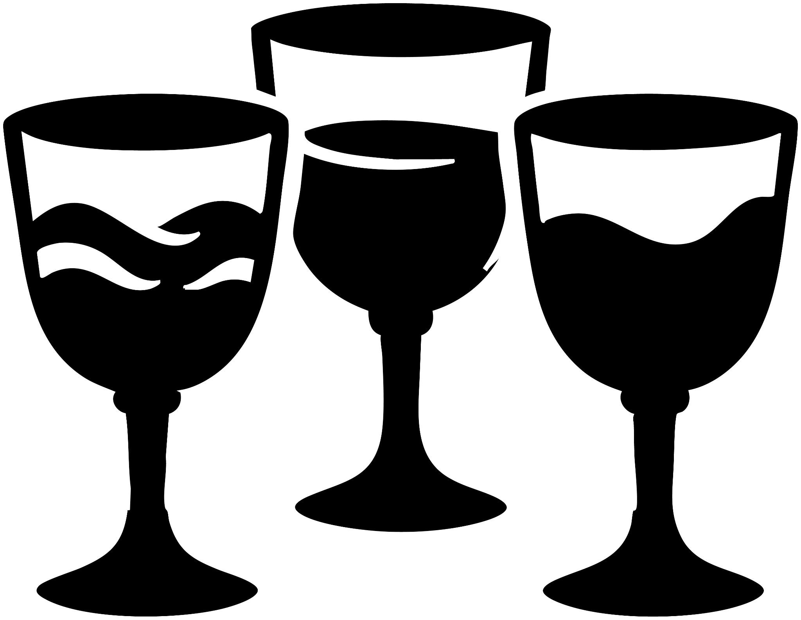

The Three Cups
As the light faded, Nycolas, Alatar, and Hermione found themselves standing in a cold, ancient chamber. At its center stood an old wooden table, and upon it rested three strangely shaped cups.
Alatar stepped forward, studying them closely. Hermione, however, turned toward Nycolas. “See? It looks as though all of us were needed to open that door.”
Nycolas grunted, unimpressed, and moved to stand behind Alatar. The wizard leaned over the cups, noting the different colors swirling in each one.
“Do we all have to drink?” Nycolas asked.
Alatar looked at him in disbelief. “Do you always walk into a room and eat the first thing you see?”
Nycolas grunted again, stepping toward the table. He picked up one of the cups and raised it toward his lips.
“What are you doing?” Alatar snapped.
“Drinking,” Nycolas replied flatly.
“Don’t be a fool. These are no simple drinks—they’re poisoned, most likely. This is a test, not a feast. A test of wit, of restraint… and perhaps of how willing we are to die.”
Reluctantly, Nycolas set the cup back down. His gaze drifted toward Hermione. She had turned from them, running her fingers along the carvings on the wall. Her voice was soft, almost reverent.
“This is the story,” she murmured. “A girl, born in the Golden Kingdom on its solitary island. But she was not ordinary. She was something more. She was the Mindseer.”
She turned back to them, her expression shadowed. “It isn’t what it seems.”
Alatar’s eyes returned to the cups. “On the surface, they are nothing more than vessels. But together…” He picked them up one by one, shifting their places, aligning the engraved lines that marked their metal. Piece by piece, the image revealed itself, until at last the three cups locked into place.
With a low groan, they fused into a single object—a black heart, pulsing faintly in Alatar’s hands. Hermione and Nycolas stepped closer, both staring at the strange thing he held.
“Who do you think it represents?” Nycolas asked, his voice quieter now.
Alatar and Hermione exchanged a look. The wizard spoke first. “I don’t know. But I’m certain we’ll find out soon enough.”
At that moment, a new door appeared behind them, solid stone where there had been only wall. Alatar turned, but Nycolas was already striding forward. He seized the handle and pushed it open, revealing yet another chamber beyond.

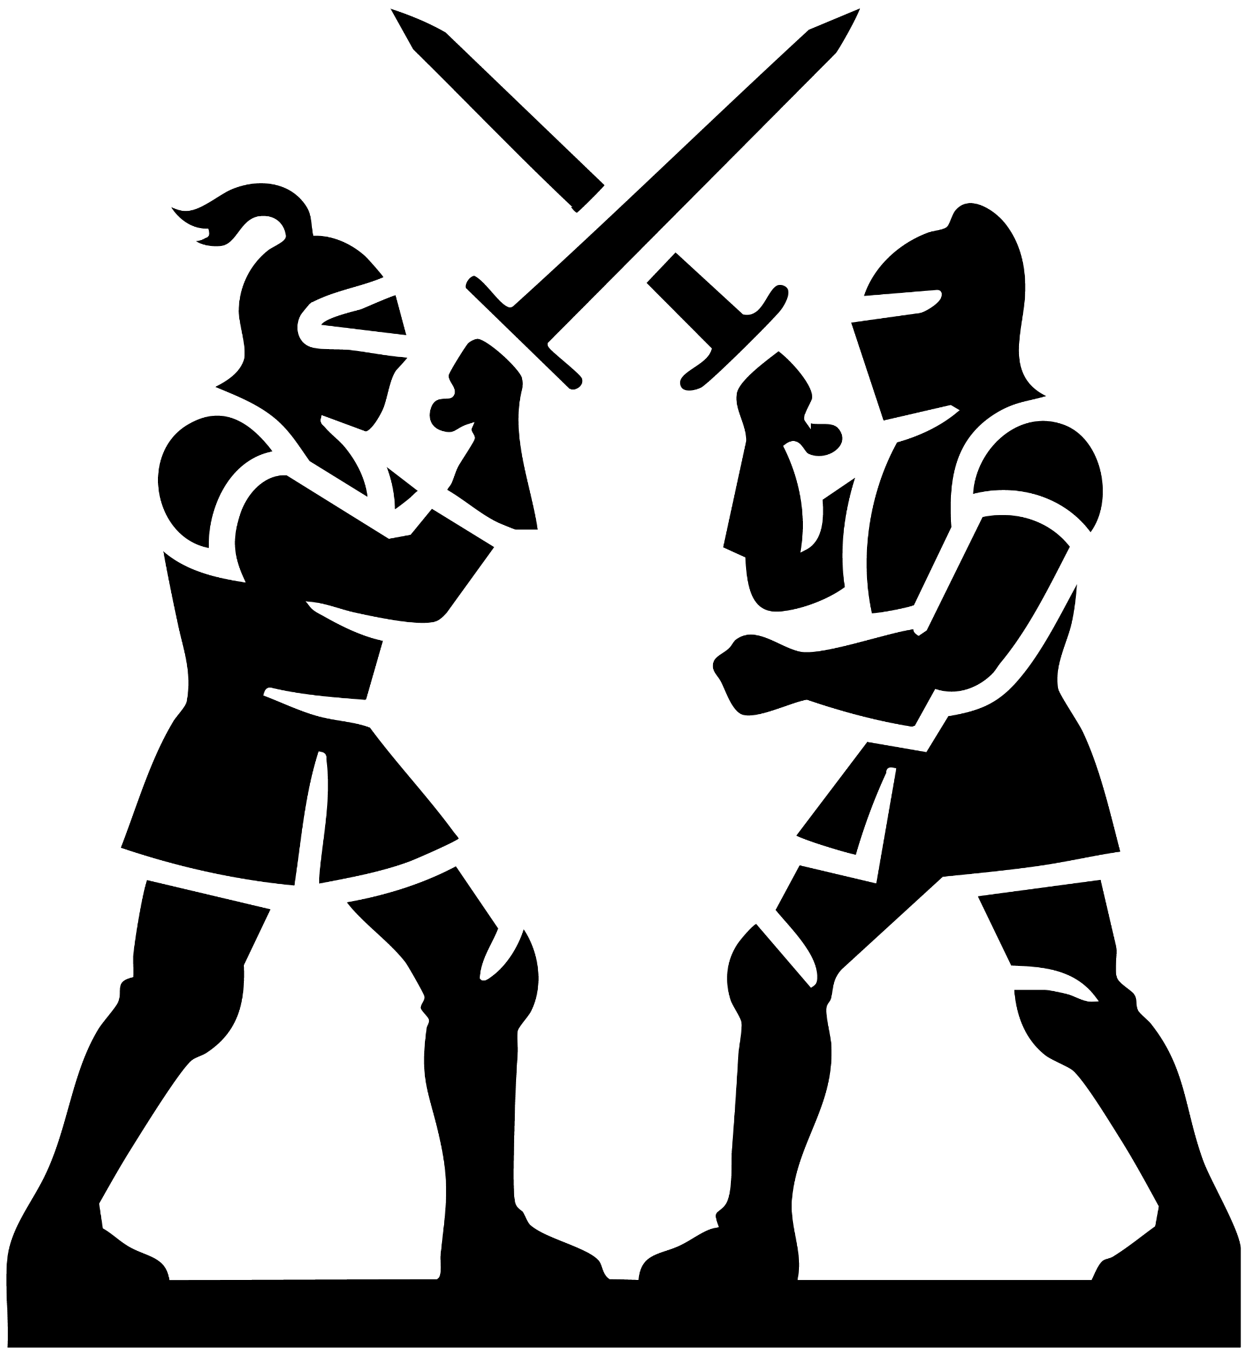

The Duel
Nycolas strode into the next chamber, his boots echoing across the stone floor. Two great stone knights stood upon pedestals at the center, their swords rising slowly, grinding against one another as they clashed in a steady rhythm.
Hermione slipped in after him, her eyes wide with unease. Alatar followed last, the black heart still cradled in his hands. His gaze lingered on the carvings etched into the chamber walls—images half-worn but still alive with old power.
Nycolas approached one of the knights and noticed a diamond set into its helm. Behind him, Hermione and Alatar studied the walls.
“What do you think we’re meant to do here?” Nycolas asked, resting his hand on his sword.
Hermione traced the markings. “My wall tells of the legend of this place—but more about the kingdom across the sea, the one that built the bridge. The tale ends there.”
Alatar nodded from the opposite wall. “Mine speaks the same, but from this kingdom’s side. It says the bridge was forged in the name of peace and trade—food, supplies, wealth shared. But…” His voice grew grim. “It feels like half a truth.”
They turned to each other at once and spoke together. “Swap walls.”
As they passed, Hermione’s hand brushed Alatar’s. In that instant, she slipped unbidden into his mind.
She saw a dim room. A young woman lay in an old wooden bed, mist curling through the air. Light from the window fell across her, casting Alatar’s silhouette into shadow as he stood at her side.
“Alatar,” she whispered weakly, “don’t give up on magic. This is only misfortune.”
His voice trembled. “This is my fault.”
The woman coughed, pain stealing her breath. “I am my own person. I made my choices. I followed you as much as you followed me. This time… it did not end well for me.”
Alatar reached for her hand, tears burning his eyes. “It should be my price to pay.”
He cut both their palms and began to speak words of power. “No!” she cried as black magic poured from her into him. His skin turned pale, thin as paper, his bones showing through, the cost etching itself upon him.
Hermione gasped as she was torn back to the present. Alatar’s eyes burned with fury as he clutched the black heart tighter. Before he could speak, she whispered, “I’m sorry. I didn’t mean to.”
He turned away in silence, walking back to the walls. Hermione swallowed her guilt and joined him.
Meanwhile, Nycolas hacked at one of the stone knights, steel ringing against stone.
Alatar’s voice cut through the chamber. “The carvings speak of peace—but a false peace. What they truly desired was this kingdom’s wealth. Look closer at the knights. Is there any difference between them?”
Nycolas glanced up, sword in hand. “Yes. One has a diamond set in its helmet.”
The stone warriors quickened, striking harder, their swords a blur. With a sharp cry, Nycolas lunged, smashing his blade against the jeweled helm. The diamond cracked free and clattered to the floor.
The knights froze. Silence fell. Slowly, they lowered their swords and stepped apart.
Nycolas bent down, scooping up the gem. In his hand, the diamond shimmered and reshaped, twisting into a necklace. Before them, the wall shuddered, then opened into a new doorway.
Hermione stepped through first, a faint smile tugging at her lips. “Nicely done.”
Alatar followed after her. Nycolas lingered for a moment, grinning to himself, before striding into the chamber beyond.



The Maze
Hermione stepped into the chamber first. The floor stretched out before them in the shape of a vast maze carved into the stone. At its entrance lay three spheres, waiting like coiled riddles. Alatar and Nycolas joined her, pausing at the threshold as their eyes swept the markings on the ground.
Hermione climbed carefully onto the raised walls of the maze, her gaze drawn to an image etched across the chamber wall—a carving of the Mindseer, hands raised, commanding men to fight against the witches and wizards who had come with the foreign king.
Alatar followed, still cradling the black heart in his hands. His eyes flicked to the spheres below. “Three balls,” he muttered. “One for each of us.”
On the far side, Nycolas studied the end of the labyrinth. Three exits waited, each marked with a colored hole. “Three paths, three balls,” he said. “I think the task is simple enough. Get them to the end.”
Hermione shook her head. “No trial is ever that simple.”
Even as she spoke, one of the maze walls ground forward, shifting with a deafening scrape. The sound echoed through the chamber like thunder.
Nycolas started back toward the entrance. “Then I’ll just carry them.”
But as he passed Hermione, her hand brushed his arm. In that instant, her sight pierced his mind.
She stood in a grand throne room, the banners of a kingdom swaying overhead. Nycolas was beside the king and queen, the princess’s hand in his. Before the gathered court, the king’s voice rang out:
“I am proud to name Nycolas, the leader who has brought us victory. I hope he will lead this kingdom to many more—my future son-in-law!”
Nycolas bent, kissing the princess’s hand. Yet as Hermione looked upward, the ceiling bled with black liquid. Darkness poured down like tar, swallowing light. Nycolas’s hands trembled. His face twisted in fear.
The vision shattered. Hermione staggered as Nycolas pulled away from her, his eyes wild.
“You saw it, didn’t you?” His voice cracked. “The darkness consuming me. Tell me you saw it!”
Hermione met his desperate gaze. “I saw it. Something was wrong. That is not normal.”
Nycolas stepped closer, pleading. “Then you understand. That is why I must kill the Mindseer. It had to be her—it must be her!”
“Or,” Hermione said softly, “you’re running from what you’ve done.”
His face hardened, pain flashing behind his eyes. “I thought, if anyone could understand… it would be you.”
Alatar’s voice cut through the tension. “Enough. The maze won’t let us lift the spheres. We can only guide them together. Our hands inside, but not taking them out.”
Reluctantly, they each moved to their places: Hermione in the center, Alatar on the right, Nycolas on the left. They bent down and touched the spheres.
At once, the world spun. Hermione gasped—her sight was not her own. Nycolas’s mind reeled as he stared out from Alatar’s body. Alatar flexed unfamiliar hands, pale and slender, Hermione’s wings bound behind him.
“Are you… Hermione?” Alatar asked, his voice strange in her throat.
“Yes,” she answered quickly, her voice now Nycolas’s.
A sharp grin crossed Alatar’s borrowed face. “Then it’s my turn.” He reached toward Nycolas’s body—Hermione trapped inside—and leapt into her mind.
The world shifted again. Alatar found himself standing in a realm of towering trees and silver light. A fairy kingdom. He saw an army assembling, marching toward the edge of the forest. Hermione stood watching, and beside her, a fairy man, his face carved in shadow.
“You can’t continue this,” Hermione cried. “If you burn the ancient trees, you will destroy all magic! Every tree balances the art!”
“You don’t understand,” the man replied, his voice low and cold. “The humans have wielded this gift too long. It was never theirs. They twist it, ruin it. The gods see. They judge every hundred years. If they are displeased, they take magic from us all. But if we strike first—if we sever the humans from the roots—perhaps the gods will spare us.”
Hermione’s wings trembled as her voice rose. “No. I will not accept that. I will gamble with the gods before I betray all magic.”
She turned to fly, but the man hurled a black chain. It struck her back, snapping tight around her wings. She cried out as she fell.
Alatar was hurled out of her memory, back into the shifting maze. Hermione’s voice, fierce with anger, rang in his ears: “That memory was not yours to take.”
Alatar clenched the black heart tighter. “Now you know how it feels. Enough. Let’s finish this.”
The three pressed their hands back to the spheres. Their minds spun, bodies trading again and again, until—through shared strength—they guided the balls along the twisting maze. With a final push, each rolled into its marked hole.
The light dimmed. Their minds snapped back into their own bodies. Hermione staggered, clutching her chest. She looked down. A black brain pulsed in her hands.
Before them, a door of white fire formed in the stone wall.
Without speaking, the three passed through together.



The Mineseer
Alatar, Hermione, and Nycolas stepped forward—and found themselves in a kingdom caught in the amber of a single moment. People ran for the bridge, but their feet never touched the ground. A bucket tipped midair, water spilling and hanging there like glass.
Alatar approached a man in black armor, frozen in the act of flight. “This is… wrong,” he murmured. “It’s as if they trapped this instant in time.”
“Why are we here?” Hermione asked, eyes flicking to Alatar.
Nycolas reached toward the suspended water; the surface quivered without falling. Alatar glanced down. The black heart in his hands had begun to glow a deep, steady red. “Check your tokens,” he said. “Are they glowing?”
Hermione lifted the black brain. It pulsed green. Nycolas touched the necklace at his throat; blue light gathered in the gem.
“They’re guiding us to something,” Alatar said.
“Or someone,” Hermione answered.
The lights grew brighter as they moved deeper into the silent streets, until they reached the broad steps at the heart of the city. Ahead, the king sprinted from the throne room—frozen mid-stride—while raw magic flared and crackled beyond the doors.
Alatar ran first. Hermione’s breath caught. “We’re inside the legend.”
“I don’t like this,” Nycolas muttered, following.
They entered the throne room. Witches and wizards locked in battle stood rigid as statues, spells frozen halfway between their hands. At the center, Alatar halted beside a young woman—the Mindseer.
“She’s the girl from the story,” he whispered. “All of this… because of her.”
He looked down; the heart in his hands no longer black, but burning red. Hermione’s brain blazed green. Nycolas’s necklace shone bright blue.
“I think these are hers,” Alatar said.
The Mindseer turned. Her hand snapped to Alatar’s throat, lifting him with terrifying ease. With the other, she plucked the red heart from his grasp and pressed it to her chest. She inhaled sharply. Color returned to her cheeks.
Her gaze slid to Hermione and Nycolas. “Are those mine?”
“Yes,” Hermione said.
Black magic rippled from the Mindseer. The green brain tore from Hermione’s hands and flowed into the Mindseer’s skull; the blue necklace slipped from Nycolas’s throat and coiled around the Mindseer’s wrist. She smiled. “Thank you.”
Alatar lunged for the necklace. The Mindseer flicked her fingers, and a dark force hurled him backward into Hermione and Nycolas. They crashed to the floor.
The frozen world shattered. Time roared back. The city buckled into ruin—the same broken kingdom they had crossed to reach this place.
The Mindseer stood over them. “You have freed me from my confinement,” she said softly. “For that, I will grant your gifts.” She studied them in a line, one by one. “The one who seeks what was lost. The one who would break a curse. And the one who wishes to forget.”
“I’m not here to forget,” Nycolas snarled, drawing his sword. “I’m here to kill you.”
Her smile did not reach her eyes. “What difference is there?”
She raised her hand. Black magic tore like smoke from each of them. Alatar gasped as the color rushed back under his skin; the stark scaffolding of bone faded. Chains clattered from Hermione’s wings and vanished. The fog in Nycolas’s mind split apart—memories rushing in, bright and terrible.
They collapsed as the black liquid bled out of them, pooling on the stone. Hermione pushed herself up, trembling. “It was you,” she said. “You attacked Alatar and his friends. You bent Nycolas with your mind and sent him against his own people. You took my father and bound your curse onto my back.”
“Yes,” the Mindseer said, almost playful. “I moved each piece, and you brought them home to me. Tell me—what will you do when a knight is already swinging?”
Nycolas’s eyes went inky black. His fingers tightened around the hilt. He slashed at Hermione.
She sprang upward, wings beating, hovering out of reach. Alatar flung up a wall of blue light between them; Nycolas hammered at it, blade ringing.
The Mindseer turned and walked for the shattered doors, unhurried.
Alatar’s jaw set. “Hermione—draw him outside. Keep him busy. I’ll deal with her.”
“Are you sure you’re strong enough?” she called.
A tired smile touched his mouth. “Of course.”
Hermione vaulted the wall in a flash of wings. “Come on, knight!” she shouted, and Nycolas charged after her, sword raised, as she lured him through a side exit and out into the ruin.
Alatar snatched up a shard of fallen stone and slung it with a crack of blue force. It struck the pillar beside the Mindseer, halting her mid-step.
“You think you can just walk away?” he shouted.
She turned, amused, as Alatar’s hands carved sigils in the air, quick and precise. “You truly believe you stand a chance against me?” she asked.
Her palm lifted. Her eyes fixed on his. She reached for his mind.
But Alatar’s pattern was already woven—a reversal sigil, bright and cold. Her power struck it and rebounded. The Mindseer’s gaze snapped inward, snagging on her own snare. She convulsed, then went eerily still, trapped inside the labyrinth of her mind.
The kingdom groaned. Stones split. The floor heaved. Alatar ran for the arch, dodging falling beams as the ceiling came down.
Outside, Nycolas blinked as the blackness fled his eyes. He and Hermione raced along the road that had once split the sea; even as they ran, the water began to return, sluicing over the stones. Hermione seized Nycolas by the arm and shoved him ahead, wings beating hard.
They reached the bridge’s threshold as the path behind them vanished beneath the waves. Hermione stumbled, crashing to her knees and dragging Nycolas down with her. Water thundered back into place, erasing the road.
She lifted her face, breathless. “Where’s Alatar?”
Nycolas rose, staring into the white churn where the path had been. He swallowed. “I’m sorry.”
Hermione stood and pulled him into an embrace. Her tears soaked his shoulder as the sea roared, and the sunken kingdom slipped silent beneath the water once more.
Blue light blossomed at their backs; they turned as Alatar emerged, wrapped in a halo of magic and smiling. Hermione met his gaze. “We did it.” The three moved on to their next quest. With the water roaring behind them, they knew they were stronger together than alone.

